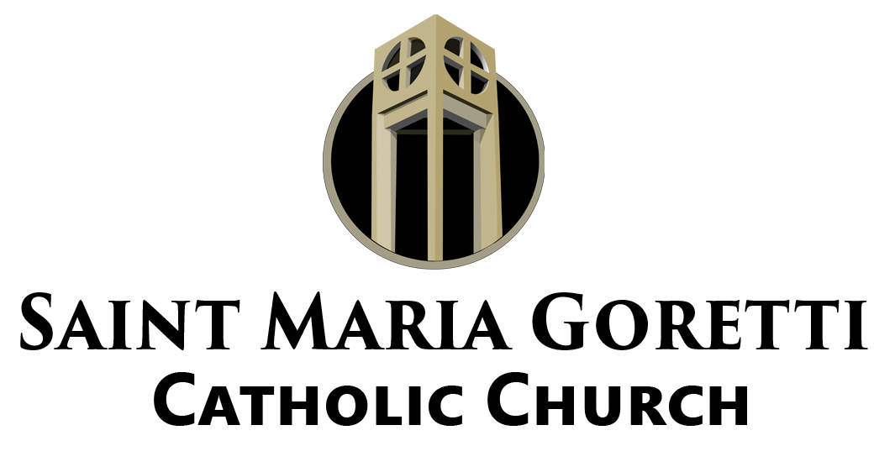

Lectio Divina:
The Process of the Divine Reading

Step 1: Read
Choose a passage of Scripture and read it through for basic understanding. The passage does not need to be long, one to two verses can sometimes be a minefield. This first reading is just to give you a familiarity with the text. After you have read the text, pause for a moment and allow the Word to sit with you.

Step 2: Meditate
After sitting in silence for a few moments, read the passage a second and maybe even a third time. This time read slower and pay attention to any word or phrase that strikes, challenges, affirms, or unsettles you. Then spend a minute or two with that word or phrase.

Step 3: Pray
After meditating upon the Scripture, ask God to speak to you. “Lord, what is it that you are trying to communicate to me? What do you desire me to know? What do you desire me to see? What do you desire for me?” Spend five to seven minutes listening to the Lord.

Step 4: Contemplate
After you have prayed, then spend a few minutes in silence. Sit with what you have received. Just be with the Word of God.

Step 5: Act
Lastly, now is the time to “do” what the Word has instructed. Follow the prompt of the Lord and be about His business.

